Dayton-Hudson (Target) Corporation

Jasmine Roberts

Bowie State University

CTEC 410-101SPRG2024

Henry Okonofua

March 13, 2024

**Introduction 4**

**History and Background 4**

Networking Concepts 5

1. Point of Sale (POS) Computers 5

2. Barcode Reader / NPC scanner 5

3. Wireless WAN 6

4. Artificial Intelligence (AI) 7

5. Price Scanner for Customers 8

6. Non-Fungible Tokens 8

7. Retail Video Analytics 9

Diagram of The Dayton-Hudson (Target) 10

Diagram 1: Target 10

Diagram 2: Super Target 10

**Target vs. Super Target 11**

Target: 11

Super Target: 11

**Company Locations 12**

Sites: 12

Branch Offices: 12

Number of Employees: 12

Industry and Market: 12

Services and Products Manufactured 13

1. Drive-up and Delivery 13

2. Same day Delivery with Shipt : 13

3. Order Pick-up: 13

4. 2-day shipping: 13

**Stakeholders ( Customers, partners, government, HIPPA, FERPA, Legal Policies) 13**

Sustainability and Governance Policies 13

Climate: 13

Circularity: 13

Resource Use: 13

Human Capital Management: 14

Diversity, Equity & Inclusion: 14

Serving and Strengthening Communities: 14

Ethical Business: 14

Responsible Supply Chains: 14

Stakeholder Engagement 14

**Network of The Dayton Hudson (Target) Corporation 16**

Topologies 16

WAN: 16

LAN: 16

**Configuration of: 17**

1. Server 17

**Active Directory 17**

**Domain and Subnets 18**

IP address ranges 18

DHCP scopes 19

URL- uniform resources locator 19

# Introduction

Have you ever wondered how Target operates their store technical wise? This project will symbolize the basic needs to run a retail store with technology. As technology becomes a more popular way of life in retail, which would ensure seamless operations and having good interaction in customer experiences.

# History and Background

The founding of Target was founded in 1961, by George Dayton and was then named Dayton’s Explored Discount retail. He created a company called “ The Dayton Company”, and they looked for new ways to strengthen relationships with guests and company leadership. On May 9, 1961 The Dayton Company was discovering a new discount store chain. Which would combine quality merchandise at discounted prices and groceries.It became the Dayton-Hudson Corporation after merging with the [J.L. Hudson Company](https://en.wikipedia.org/wiki/Hudson%27s) in 1969 and held ownership of several department store chains including Dayton's, Hudson's, Marshall Field's, and Mervyn's. In 1962, The Dayton Company decided to name the retail store “Target”, with a bullseye logo. The bullseye logo was used up until 1968 by removing one of the red circles. Months later, the first four Target stores opened in Minnesota St, Louis Park, Crystal, and Duluth. In 1966, Target opened two stores in Denver Colorado as its further steps into making the supply chain national.

In 1967, The Dayton Corporation transformed into a national retailer. Target has five divisions such as Dayton’s department store, Target Stores B.Dalton Bookseller, Dayton Jewelers, and Dayton Development Company. The expansion helped open new doors such as management, community giving, and good corporate governance. In 1969, Target First Distribution Center opened in Fridley Minnesota. In 1971, Target was the first barrier free store in Denver with its accessibility and to hire people with disabilities. In 1988, the introduction of UPC Scanning was invented and was the first in-store technology they had. In 1989 Target expanded from just one store in Minnesota to 400 stores across the United States. The company was originally named Goodfellow Dry Goods in June 1902 before being renamed the Dayton's Dry Goods Company in 1903 and later the Dayton Company in 1910.

Lastly, with knowledge of Target’s history and background it will be easier to understand the importance of this report as Target being the subject and how it is being conducted. Target is the goal of this report, and its features will be explained in technology terms and demonstrations will be shown on how they operate with technology. People who like to be informed or influenced may have questions on how Target may operate as a whole. Such as, what technology mechanisms do they use?, this report is just for you.

# Networking Concepts

This section will be demonstrating several networking concepts and diagrams of the relevant technologies at a high level.

## Point of Sale (POS) Computers

A Point of Sale system maintains the records of transactions and items sold within a store. Point of Sale computers are used daily inside of Target to complete a sales transaction. At the point of sale a sales item is scanned within the scanner and the price of the item shows up on the POS computer to symbolize how much is owed. POS computers are cloud based machines. A POS Computer can optimize the checkout process which would help the speed of the line by having a database of Target’s products, pricing, and customers. It can provide more payment options, as we know cash and card or the normal ways to pay but, ewallet has come into existence, installments or combined different methods to pay for your order.

## Barcode Reader / NPC scanner

A Barcode reader is a hand-held device that is used to capture and read information that is inside of a barcode. Barcode reader/ NPC Scanner is a scanner that reads a barcode that is located on any item at Target to capture its information. The scanner converts the light energy into electrical energy, which is then converted into data by the decoder and forwarded to a computer. The barcode reader translates the barcode into numbers and letters. Some advantages of barcode readers in retail are reducing the amount of pricing errors, increasing efficiency of the item, and reduced inventory levels.

## Handheld Barcode Readers

The Handheld Barcode Reader is in your hand while you scan an item, and you press the red button below to scan the item. It scans physical items into digital format, which means it can be stored and transferred within the digital network. It consists of an actual reading unit and a decoding unit. The decoding unit would pertain to the reading unit which would be used mostly in retail.

## Fixed Position Barcode Readers

The Fixed Position Barcode Reader is built to stay in one spot at all times. They are good for situations that deal with fast moving items. They are permanently installed in a fixed location, such as for Target in checkout counters. They are designed for high-volume scanning tasks.

## Wireless WAN

Wireless WAN would be efficient for use inside of Target because you can connect each device wirelessly; it doesn't need to have any cordlike connection. WAN is mostly used for larger enterprises such as Target. WAN provides a wireless network anywhere in the network providers coverage zones for access. It provides connectivity for a range of situations that are not suitable for LAN. There are two types of WAN Technologies to be used:

1. Carrier 4G LTE/5G public networks

This would be used in a large area, providing a secure connection for devices that join a network

1. Private 4G LTE/5G networks

This would be used the same as Carrier 4G LTE /5G public networks, but it is a private carrier.

## Artificial Intelligence (AI)

Artificial Intelligence is a technology that allows a computer/machines to simulate human intelligence and problem solving capabilities. This would be referred to as machine learning such as different AI algorithms and decision making processes as if it had a human brain. Target uses AI for assortment planning and stock count. Also, AI is used to ensure that inventory is in the right locations and keeps items from going out of stock. There are four types of Artificial Intelligence.

Reactive Machines which carry out specific commands and requests, cannot store memory or reply on past experiences to enforce its decision making and are limited on tasks.

Limited Memory which has the ability to store previous data and predictions, can gather information and make decisions. Limited Memory is created when a team constantly trains a model on how to utilize new data.

Self-Awareness has a sense of self, human like consciousness and it can under its own existence

## Theory of Mind, which can understand human emotions, uses information to predict future actions and make decisions on its own.

## Price Scanner for Customers

Price Scanner for Customers is used for reading price information on an item's barcode into a computer system. Target uses a price checker for customers to scan their item(s) and find out the price. The customer would scan the barcode and the device responds with a price.

## Non-Fungible Tokens

Non-Fungible Tokens are unique identification codes created from metadata within encryption functions. The tokens are stored on a blockchain, NFTs can be traded and exchanged for money, and cryptocurrencies. NFT are assets used to create and authenticate ownership of digital assets.

Within Target, a Non-Fungible Token is being put into highly effective use as far as stock. NFT serves as a digital representation of items in the store. There are many benefits of NTF in retail such as Authenticity, Loyal Programs, Ownership, Digital Goods, Enhanced consumer engagement, and Provenance.

## Retail Video Analytics

Retail Video Analytics is a technology that extracts information and insights from video footage. It can enhance security monitoring. Reduces manual effort and enhances data-driven decision making for retailers of its operation. This is a way to monitor retails, the other ways to monitor is count customers enter/exit, head count of customers, pedestrian count, crowds of people lingering in front of displays, analyze consumer demographics, analyze store layout and navigation, optimize promotions, products displays, manage demands, manage inventory and marketing campaigns.

Target uses Retail Video Analytics to digitally record customers and identify behavioral patterns and trends. It provides Target actionable intelligence of their store. This can also be a form of security and prevention.

## VPN

VPN can be used to protect sensitive data, such as financial transactions, employee information, and customer data. It can also access geo-restricted content and provide remote access to your network. VPN can give [remote employees](https://www.cloudflare.com/learning/access-management/remote-workforce-security/) access to internal applications and data, or to create a single shared network between multiple office locations. The VPN makes an internet connection more secure and offers both privacy and anonymity online.

## Cross Band-Network

Operation is a method of telecommunication in which a radio station receives signals on one frequency and simultaneously transmits on another for the purpose of full duplex communication or signal relay.

## Routers

Customers expect Wi-Fi internet access in stores, improve responses to customers and enable easier access to customer information. These are real benefits at a time when customers demand fast answers to questions, as well as personalized service.

This is a topology on how it would like to network:

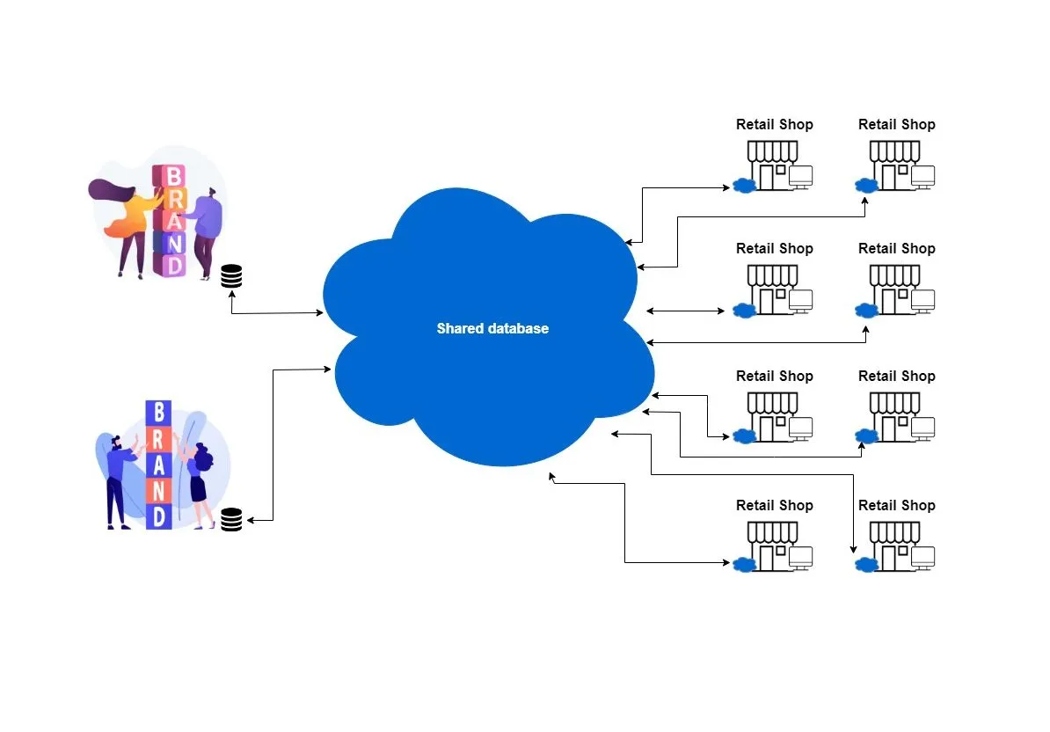

# 

# 

# 

# 

# Diagram of The Dayton-Hudson (Target)

## Diagram 1: Target Home Depot vs Target: A store layout analysis | by Saira Tabassum | Medium

## 

## Diagram 2: Super Target 2011 Target store map - interior | Filmscore | Flickr

#### 

# Target vs. Super Target

## 

## Target

Regular stores focus on everyday items, with a smaller selection of groceries. It's a smaller sized store, located in more urban.suburban areas. They are more focused on affordable products instead of their aesthetic.

## Super Target

## Super Target is larger, has a full grocery section, and stuff like an on-site bakery, deli, etc. They also usually have two sets of doors on the front of the store, one of which goes on the grocery side.They have more space for products and customers. Super Targets are located in more rural locations. They balance out between grocery and everyday items.

Target

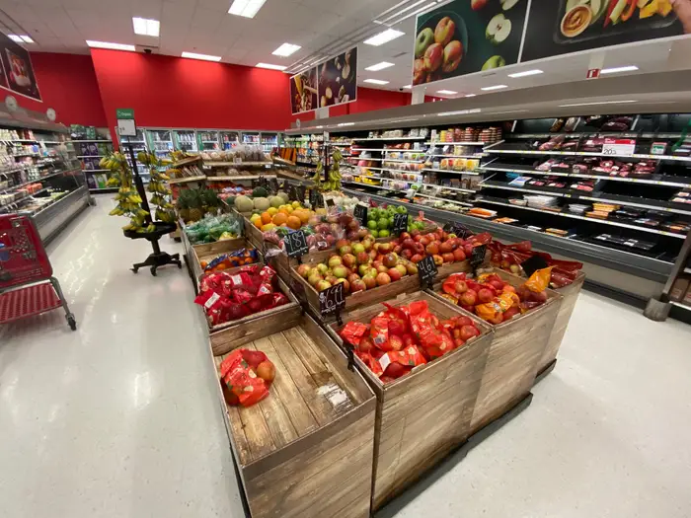

Super Target

# Company Locations

## Sites

There are 1,897 Target Stores in the United States. The stores are located in 51 states and 1,299 cities.

## Branch Offices

## There are 9 Branch offices of Target, eight of the branches are in the United States, and one of the branches are in India

## Number of Employees

Target has 150 employees all together

## Industry and Market

Target is a department store that sells groceries, clothing for men.women children and infants, baby products such as toys, food, diapers, wipes, cameras, cribs etc., Office Supplies, Toiletries, Hair Products, and Feminine Hygiene etc.

**Other Target Locations**

Connected Commerce: Salt Lake City

Target Enterprise Services: Tempe, Arizona and Sioux Falls, South Dakota

Government Affairs: Washington, D.C.

Marketing: New York City

Silicon Valley office: Sunnyvale, California

Target Print Services: Brooklyn, MN

Marketing Photo Operations: Minneapolis, MN

# Services and Products Manufactured

## Drive-up and Delivery

Shop on the Target app and choose your store. is a free and convenient grocery pickup option. They will bring your purchase right out to your car. Drive Up allows you to order items from the Target app, and usually within 2 hours, we'll bring them out to your vehicle when you arrive at the designated Drive Up parking spaces at your local Target store. Drive Up is available on the Target app for iOS and Android only.

### Same day Delivery with Shipt

You can order from home on Target.com, and your Shipt shopper will do the shopping for you and place your purchases right at your doorstep.Shipt delivers seven days a week with the exception of certain holidays, and shoppers are available whenever the store is open. Deliveries can be scheduled for a one-hour window as soon as one hour after your order is placed. You'll be able to select Drop-off delivery to have your delivery left at the door.

#### Order Pick-up

Order ahead and Target will have your purchase waiting for you at the Order Pickup counter.Order Pickup allows you to order items on Target.com or in the Target app and pick them up for free at your local Target store. Your order will usually be ready within 2 hours of placing your order.

|  |
| --- |
|  |

#### 2-day shipping

Rush your purchase to be deliver in one or two days.Your item(s) are expected to be delivered within 2 business days after the items have been shipped and picked up by the delivery carrier. For eligible items, spend $35 or more, or place your order using your RedCard and receive free 2-day shipping

# Stakeholders ( Customers, partners, government, HIPPA, FERPA, Legal Policies)

## *Sustainability and Governance Policies*

Climate consists of Greenhouse gas emissions, and climate-related risks and opportunities.Circularity consists of product and package design, and waste elimination and reduction. Resource Use consists of environmental impacts of products,water use and management chemicals and Biodiversity. Human Capital Management consists of compensation, benefits and well-being ,workplace health and safety, talent and development. Diversity, Equity & Inclusion consist of board and workplace diversity. Serving and Strengthening Communities consist of community impact and access to products and services. Ethical Business consists of government advocacy, privacy and cybersecurity, product quality and safety. Responsible Supply Chains consist of purchasing practices,human rights and animal welfare.

**Stakeholder Engagement**

**Business Partners**

All vendors include Business Partner Code of Conduct, Capability building, Standards of Vendor Engagement, Training and workshops, Vendor Portal, and Cendor surveys.

**Merchandise vendors**

All vendors include Annual assessment, Annual meetings, regular ongoing meetings, and topical calls.

**Civil society organizations**

All vendors include Partner visits and community dialogues, Collaborations to advance shared priorities, Contributions through community partnerships and volunteerism, Philanthropic investments ,Trust-based philanthropic approach, Select topical engagement, Memberships and coalitions, Participation in conferences and forums and Strategic relationships and consultation on priority issues.

**Government officials and influencers of public policy**

All vendors include Direct legislative advocacy as Target, Informational discussions with government officials, Advocacy through trade associations and/or in partnership with other companies and Grassroots advocacy.

# Network of The Dayton Hudson (Target) Corporation

## Topologies

Both WAN and LAN would be useful for Target it just depends on the store

### WAN

This type of network would be the most useful for Target. WAN provides more widespread connection between devices, and can connect however many devices wirelessly.Wireless WAN would be efficient for use inside of Target because you can connect each device wirelessly; it doesn't need to have any cordlike connection. WAN is mostly used for larger enterprises such as Target. WAN provides a wireless network anywhere in the network providers coverage zones for access. It provides connectivity for a range of situations that are not suitable for LAN.

#### LAN

This type of network would be the most useful for Target, LAN provides a connection within a collection of devices together in one setting/location such as an office. LAN networking requires Ethernet cables and Layer 2 switches along with devices that can connect and communicate using Ethernet. Larger LANs often include Layer 3 switches or routers to streamline traffic flows. A LAN enables users to connect to internal servers and other LANs that belong to the same wide area network (WAN). Most of the time, WAN and LAN are used together to have a more functional connection. In Target the Back office would consist of a gateway, firewall, router, LAN, WLAN.

In Target the Customer Area it consists of WiFi Network, Surveillance Cameras, and POS/ Cash Register.

A Data Center would consist of Secondary WAN 4G-LTE Cellular, and Primary Connection such as cables.

# Configuration of:

## Server

Step 1: Set the Server Backup

Step 2: Set up remote access

Step 3: Set sharing options

Step 4: Set the server as domain

Step 5: Allow all computers to join the network

Step 6: Allow the server to authenticate user credentials

Step 7: Add a local admin account to each PC

Step 8: Organize and upload the data and applications

The server of Target would include 5 or more clients(desktop/laptops), a switch, and a firewall.

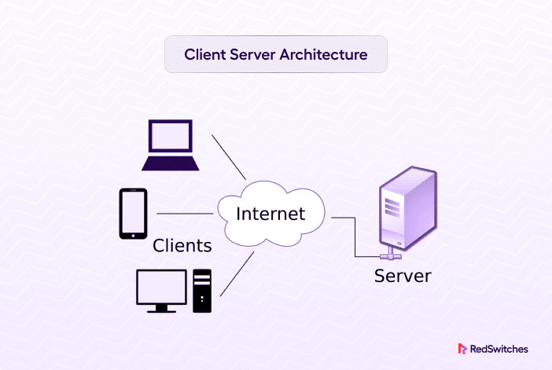

# 

# 

# 

# 

# Active Directory

Active Directory stores information about objects on the network and makes this information easy for administrators and users to find and use. Active Directory uses a structured data store as the basis. The Active Directory includes a set of rules, the schema, that defines the classes of objects and attributes contained in the directory, the constraints and limits on instances of these objects, and the format of their names. An object is a single element, such as a user, group, application or device such as a printer. Objects are normally defined as either resources, such as printers or computers, or security principals, such as users or groups. Active Directory categorizes directory objects by name and attributes.

The Active Directory has five services such as Lightweight Directory Services, sharing similar functionalities, such as the application program interface. AD LDS, can run in multiple instances on one server and holds directory data in a data store using Lightweight Directory Access Protocol. Lightweight Directory Access Protocol is an application protocol used to access and maintain directory services over a network. LDAP stores objects, such as usernames and passwords, in directory services. Certificate Services generates, manages and shares certificates. A certificate uses encryption to enable a user to exchange information over the internet securely with a public key. Active Directory Federation Services authenticates user access to multiple applications, even on different networks using single sign-on. As the name indicates, SSO only requires the user to sign on once, rather than use multiple dedicated authentication keys for each service. Rights Management Services control information rights and management.

In 2013, there was a Target data breach where hackers gained access to the retailer's network. Here's a detailed explanation of how they took advantage of AD:

First Point of Intrusion: Credentials from Target's HVAC contractor were stolen by attackers.

Infiltration and Propagation: They further penetrated Target's network by using these pilfered credentials.

Credit Card Information Was Taken: In the end, they were able to obtain credit card information from a Point of Sale (PoS) system that was not online.

Comprehending this assault is essential since those who carry out similar actions continue to operate, jeopardizing other PoS systems.

Complex IT infrastructures, such as Active Directory for user authentication, group policy management, and other directory services, are often used by businesses like Target to run their operations.

It's difficult to give accurate information about Target's implementation without knowing specifics about their Active Directory configuration. The Active Directory configuration within an organization can differ depending on a number of factors, including its size, structure, security needs, and IT policies.

Here is one on the active directory system that was used on:

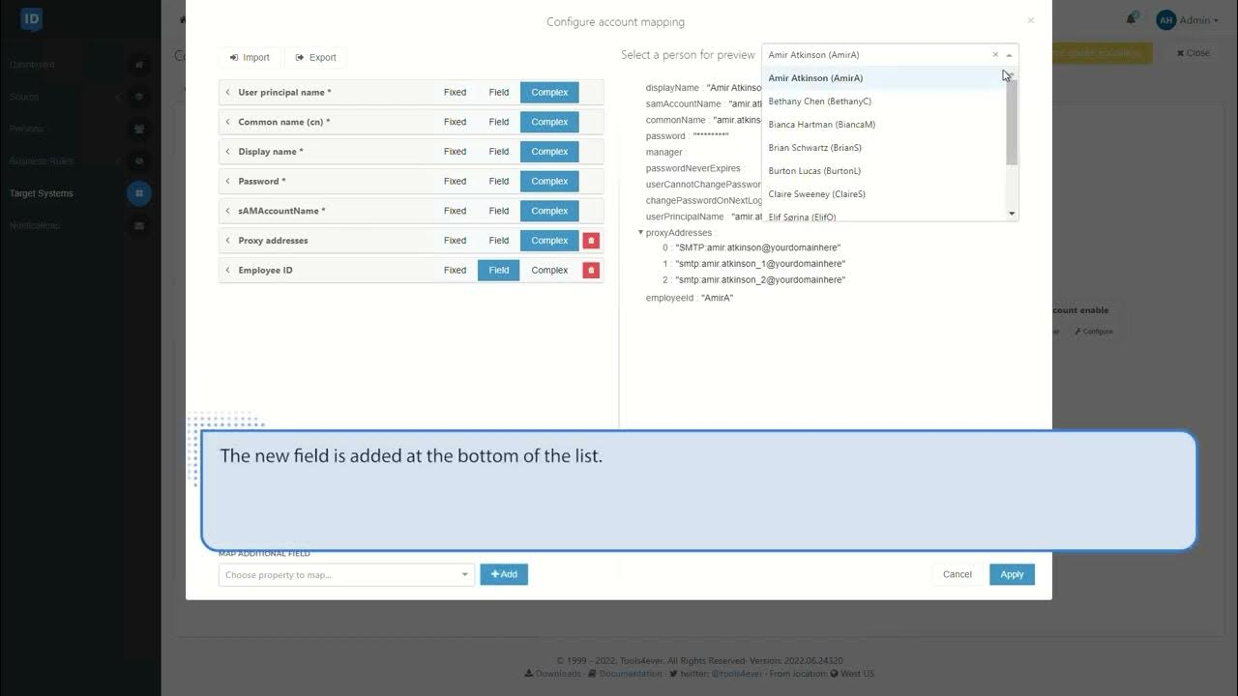

# Domain and Subnets

Domain name is a string that identifies a realm of administrative autonomy, authority or control. Domain names are often used to identify services provided through the Internet, such as websites, email services and more.Subnetting helps in organizing the network in an efficient way which helps in expanding the technology for large firms and companies. Subnetting is used for specific staffing structures to reduce traffic and maintain order and efficiency. Subnetting divides domains of the broadcast so that traffic is routed efficiently, which helps in improving network performance.Subnetting is used in increasing network security.

For security reasons, Target Corporation's internal network details—including subnet and domain information—are not made public. Usually, businesses keep this kind of information private in order to guard against illegal access to their network infrastructure. You should follow any security and privacy policies that Target may have in place and contact them directly through their official channels if you need information about their network for legal purposes.

## IP Address Ranges

There are 277 domain names hosted across 4 IP addresses..

|  |  |  |
| --- | --- | --- |
| **IP ADDRESS** | **DOMAIN** | **DOMAINS ON THIS IP** |
| 161.225.130.163 | httptarget.com | 147 |
| 161.225.130.97 | shopsontarget.com | 123 |
| 161.225.195.239 | targetnationalbank.com | 3 |
| 161.225.203.239 | targetgifmaker.com | 3 |

### DHCP Scopes

DHCP Scope is an administrative grouping of IP addresses for computers on a subnet that the DHCP server can lease to clients. When you define one or more scopes on your DHCP server, the server can manage the distribution and assignment of IP addresses to DHCP clients. There are three types of scopes and they are Single Scope, Multicast Scope and DHCP Superscope. A single scope is the simplest configuration possible in DHCP. A single scope is a range of IP addresses and associated configuration options within the DHCPt. Multicasting in Windows is the process of sending a message to a group of recipients, in contrast to a message that's sent to a specific recipient. DHCP Superscopes are an administrative feature of DHCP server you can use to group multiple scopes as a single administrative entity. Across the country, Target is a well-known retail chain. It is probable that Target's IT infrastructure employs DHCP scopes to oversee the assignment of IP addresses to devices situated within their stores. With the use of these scopes, you can make sure that the right IP addresses and network configuration are assigned to devices (like cash registers, inventory scanners, and staff workstations). Target uses DHCP, which is a common way for large organizations to manage IP address allocation effectively.

#### URL- uniform resources locator

A uniform resource locator, colloquially known as an address on the Web, is a reference to a resource that specifies its location on a computer network and a mechanism for retrieving it. https://www.target.com/ is the official website for Target department stores. Clients can explore and buy a variety of products on Target's online shopping platform by using this URL.

**Website DNS IP Address (Forwards, reverse lookup DNS)**

The DNS lookup tool finds the IP address of any domain name, returning IP addresses in the DNS records received from the name servers. Target DNS IP Address is 161.225.130.163 rdr3.target.com The DNS IP address for the Target department store website is 151.101.2.187

**References**

guide, s. (2024, January 16). *NFT Non Fungible Token*. Lark. Retrieved March 3, 2024, from https://www.larksuite.com/en_us/topics/retail-glossary/nft-non-fungible-token

Hanna, K. T. (n.d.). *What is a barcode reader (POS scanner, barcode scanner, price scanner)?* TechTarget. Retrieved March 3, 2024, from https://www.techtarget.com/whatis/definition/barcode-reader-POS-scanner-bar-code-reader-price-scanner

*How To Set Up A Server For A Business | Avast*. (n.d.). Avast Blog. Retrieved March 3, 2024, from https://blog.avast.com/setup-server-business-avast

Li, T. (n.d.). *What Is a POS System and How Does It Work?* Investopedia. Retrieved March 3, 2024, from https://www.investopedia.com/terms/p/point-of-sale.asp

*Number of Target stores in the United States*. (n.d.). Scrape-It.Cloud. Retrieved March 3, 2024, from https://scrape-it.cloud/brand-reports/target

*Pickup & Delivery*. (n.d.). Target Corporation. Retrieved March 3, 2024, from https://corporate.target.com/about/products-services/pickup-delivery

*Sustainability & Governance Priorities*. (n.d.). Target Corporation. Retrieved March 3, 2024, from https://corporate.target.com/sustainability-governance/governance-and-reporting/priorities

*Target History Timeline*. (n.d.). Target Corporation. Retrieved March 3, 2024, from https://corporate.target.com/about/purpose-history/history-timeline?era=2

*Target's Products & Services*. (n.d.). Target Corporation. Retrieved March 3, 2024, from https://corporate.target.com/about/products-services

*What is WAN? - Wide Area Network Explained*. (n.d.). AWS. Retrieved March 3, 2024, from https://aws.amazon.com/what-is/wan/